**Assignment 4 Answers**

Question 1

For part 1, we downloaded the CIFAR-10 dataset. We then normalized the dataset to have values between 0 and 1 instead of 0 to 256, by dividing by 255. We also “one hot” encoded the labels. This dataset contains 32x32 rgb images, which differs from MNIST’s 28x28 greyscale images. We therefore represented the images as a layered image with a depth of 3 for the red, blue and green images. We then altered the cnn.py code so that the ‘X’ placeholder now takes 32x32x3 input values. The convolutional filter was changed to 3x3x3 in order to filter in depth. The next hidden layer weights were changed to be 32x16x16.

Question 2/5

To investigate 5 different model scenarios, we originally kept the one convolutional layer and changed the max pool filter from 2x2 to 3x3 to 4x4. We then added a convolutional layer and used max pool layers of 2x2 and 3x3. The accuracy results for 15 epochs are shown in the table below:

|  |  |  |  |  |  |
| --- | --- | --- | --- | --- | --- |
| Epoch | 1 Conv. layer | | | 2 Conv. layers | |
| Max Pool (1,2,2,1) | Max Pool (1,3,3,1) | Max Pool (1,4,4,1) | Max Pool (1,2,2,1) | Max Pool (1,3,3,1) |
| 1 | 0.3515625 | 0.28125 | 0.3515625 |  |  |
| 2 | 0.44140625 | 0.4609375 | 0.41015625 |  |  |
| 3 | 0.5546875 | 0.50390625 | 0.515625 |  |  |
| 4 | 0.546875 | 0.51953125 | 0.5078125 |  |  |
| 5 | 0.51171875 | 0.58984375 | 0.58203125 |  |  |
| 6 | 0.63671875 | 0.5703125 | 0.5625 |  |  |
| 7 | 0.6015625 | 0.6484375 | 0.65625 |  |  |
| 8 | 0.55859375 | 0.5859375 | 0.609375 |  |  |
| 9 | 0.65234375 | 0.60546875 | 0.60546875 |  |  |
| 10 | 0.625 | 0.58984375 | 0.62890625 |  |  |
| 11 | 0.578125 | 0.59375 | 0.67578125 |  |  |
| 12 | 0.6796875 | 0.6875 | 0.62109375 |  |  |
| 13 | 0.62890625 | 0.6640625 | 0.58984375 |  |  |
| 14 | 0.6484375 | 0.6640625 | 0.6328125 |  |  |
| 15 | 0.60546875 | 0.68359375 | 0.61328125 |  |  |

Question 3

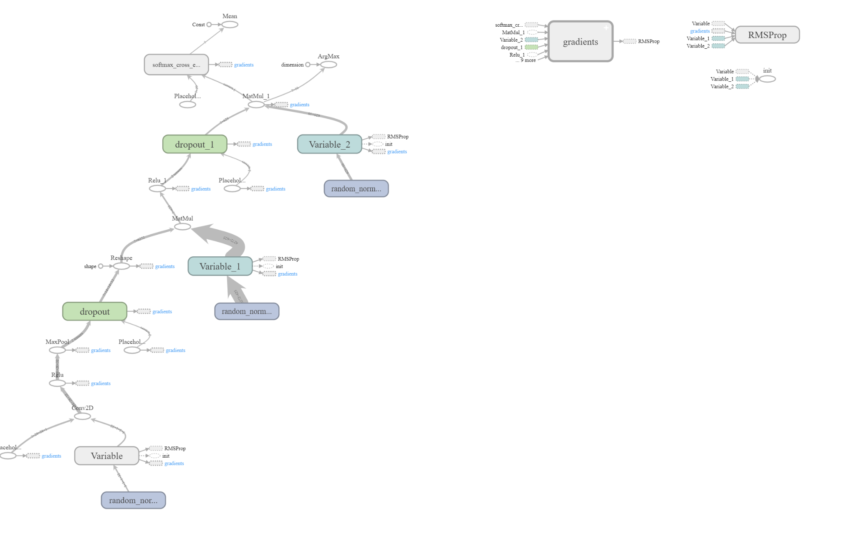

Question 6

